**Bangladesh Army University of Engineering & Technology (BAUET)**

Qadirabad Cantonment, Natore-6431



**Proposal for Integrated Design Project (IDP)**

**On**

***Title of the Project***

|  |  |
| --- | --- |
| **Submitted By:** | **Submitted To:** |
| 1. **Name:…………. (ID:……)** 2. **Name:…………. (ID:……)** 3. **Name:…………. (ID:……)** | 1. **Main Supervisor: Name & Designation** 2. **Co-Supervisor (if any): Name & Designation** |
|  |  |
| **Student of Batch:** | **Department:** |
| **Course Code:** | **Credit Hours:** |
| **Course Title:** | **Date of Submission:** |
| **Academic Semester:** |  |

**Remarks**

**Date & Signature of Evaluator**

**Department of Information and Communication Engineering (ICE)**

Table of Contents

1. Executive Summery/Background/Introduction 3

2. Review of existing project/work/product 3

3. Critical Analysis and Problem Statement 3

4. Objectives 4

5. Project Explanation 4

6. Expected Outcome 4

7. Milestone 4

8. Budget 5

9. Conclusion 5

10. Reference List 5

11. Declaration 6

# 1. Executive Summery/Background/Introduction

Start this section with a short and clear background information of your topic that could help to understand the context of your project. Give a brief problem statement indicating the purpose or scope of this project with hypothetical significant of this research. Write this section within 10-15 lines. You are encouraged to add a graphical overview or diagram of your project if possible like in the figure 1.

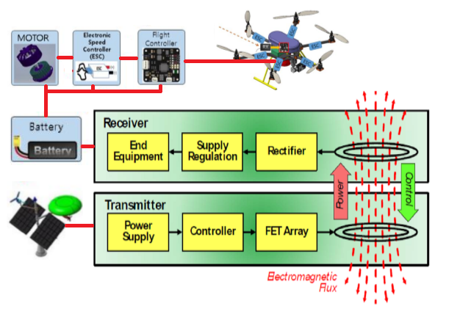

Figure 1: Overview of AI based drone system with wireless charging by inductive power transfer.

# 2. Review of existing project/work/product

In this section you have to present a summary of review. In this regard, you are required to review and present the summery of at least 10 related product/system/project/project paper most of them should be recent. You may present a summary of important reviewed data in tabular form along with enough explanation and required citation/reference.

# 3. Critical Analysis and Problem Statement

In this section you have to give your own comments based on your critical analysis on the review presented in above section indicating the complex problem based on you are going to set your research/project objectives.

# 4. Objectives

In this section you have to write clear and concise objective of your research/project. An Example is as below.

*In this research proposal, we want to develop AI based surveillance mini-Drone with automated charging by wireless power transfer system for continuous operation of unlimited time for remote surveillance and/or telecommunication network monitoring. To accomplish this goal our research work is opted into the following objectives:*

1. *To model and prototype miniaturized light weight AI based drone with precision mission control with long range control and data communication.*
2. *To develop android based appropriate controlling interface to control the operation of drone.*
3. *To design a light weight automated inductive wireless power transfer system-based drone charging system for automatically recharging drone’s batter when needed.*
4. *To implement and test the whole system and rectify for improvement.*

# Project Explanation

In this section you have to explain your project idea with required block diagram/flowchart/circuit diagram/ system representation.

# Expected Outcome

Mention few expected outcomes or novel features of your project.

# Milestone

The Gantt chart of proposed research is following (*Example):

|  |  |  |  |  |  |  |  |  |  |  |  |  |  |  |
| --- | --- | --- | --- | --- | --- | --- | --- | --- | --- | --- | --- | --- | --- | --- |
| **Tasks** | | **Project Duration (12 Months)** | | | | | | | | | | | | |
| **Semester-1** | | | | | | **Semester-2** | | | | | |
| Month 1 | Month 2 | Month 3 | Month 4 | Month 5 | Month 6 | Month 7 | Month 8 | Month 9 | Month 10 | Month 11 | Month 12 |
| 1 | Task 1 |  |  |  |  |  |  |  |  |  |  |  |  |
| 2 | Task 2 |  |  |  |  |  |  |  |  |  |  |  |  |
| 3 | Task 3 |  |  |  |  |  |  |  |  |  |  |  |  |
| 4 | Task 4 |  |  |  |  |  |  |  |  |  |  |  |  |
| 5 | Task 5 |  |  |  |  |  |  |  |  |  |  |  |  |
| 6 | Task 6 |  |  |  |  |  |  |  |  |  |  |  |  |
| 7 | Task 7 |  |  |  |  |  |  |  |  |  |  |  |  |
| 8 | Task 8 |  |  |  |  |  |  |  |  |  |  |  |  |
| 9 | Task 9 |  |  |  |  |  |  |  |  |  |  |  |  |
| 10 | Task 10 |  |  |  |  |  |  |  |  |  |  |  |  |

|  |  |
| --- | --- |
| **Task** | **Description** |
| *Task 1* | *Literature Review* |
| *Task 2* | *Modeling and implementation of AI based drone hardware* |
| *Task 3* | *Android Apps development for controlling drone* |
| *Task 4* | *Implementation of AI in drone hardware* |
| *Task 5* | *Modeling of wireless power transfer (WPT) system for drone charging* |
| *Task 6* | *Modeling transmitter and receiver coil for WPT system* |
| *Task 7* | *Modeling of inverter and rectifier circuit for power transmitter and receiver* |
| *Task 8* | *Fabrication of inductive power transfer system* |
| *Task 9* | *Testing and optimization of overall AI based drone and wireless charging system* |
| *Task 10* | *Report writing and paper publication* |

# Budget

You have to present a realistic budget for your research. One example is as below.

|  |  |  |
| --- | --- | --- |
| **Si** | **Particulars** | **Estimated Budget** |
| 1 | Purchasing research materials   1. Drone hardware materials 2. Android module 3. Wireless power transfer coil materials 4. Inverter and rectifier circuit materials | 120,000/-  20,000/-  30,000/-  60,000/- |
| 2 | Android apps development | 20,000/- |
| 3 | Allowance and honorarium   1. Allowance for researcher 2. Honorarium on publication or novel achievement | 60,000/-  40,000/- |
| 4 | Conference/Seminar and Publication   1. Attending conference/Seminar 2. Journal article publication | 45,000/-  50,000/- |
| Total | | 4,45,000/- |

In Word: Four lac forty-five thousand only.

# Conclusion

Give a concluding remark of your research proposal.

# Reference List

List all of your references in IEEE style like below.

[1] M. Wazid, B. Bera, A. Mitra, A. K. Das, and R. Ali, "Private blockchain-envisioned security framework for AI-enabled IoT-based drone-aided healthcare services," in *Proceedings of the 2nd ACM MobiCom Workshop on Drone Assisted Wireless Communications for 5G and Beyond*, 2020, pp. 37-42.

# Declaration

We are declaring that this proposal is original and not submitted anywhere else. To the best of our knowledge there is not conflict government and BAUET policy.

Signature & Date

|  |  |  |
| --- | --- | --- |
| **Name of Student-1**  **ID of Student-1** |  | **Name of Student-2 …..**  **ID of Student-2…** |