
Bangladesh Army University of Engineering & Technology (BAUET)
Qadirabad Cantonment, Natore-6431

INDUSTRIAL TRAINING REPORT
ICE 3270
Department of Information and Communication Engineering (ICE)
Logo of industry ogo of industry

Industry Name | :
Industry Address | :

Name | :
Student ID | :
Batch
Semester

MARKS DISTRIBUTION

[N.B.: For Office use only]
CO | Statement | PO | Tool | Marks | Remarks
CO1 | Apply engineering fundamentals information and concepts to adopt with industrial and modern technology. | 01 | Observation |  | Industrial Supervisor
CO2 | Practice good professional ethics and commitment to professional responsibilities. | 08 | Observation |  | Industrial Supervisor
CO3 | Perform effective oral presentation on complex engineering activities. | 10 | Presentation |  | Supervising Teacher
CO4 | Produces written engineering reports by applying principle based approaches and design documentation on complex engineering activities for different stake holders. | 10 | Report |  | Supervising Teacher
CO 5 | Recognizing the need for continuing education and participation in the broadest context of technological change. | 12 | Report |  | Supervising Teacher
Total Marks (Out of 100)

Acknowledgements
My Acknowledgement goes to the following individuals for their help, advice and support during my attachment period ….

Student Name
Student ID
Batch

STATEMENT OF ORIGINALITY

I declare that this Industrial Training report is prepared solely by myself, no part of this report is directly copied from other source. It is submitted to the fulfilment of the requirement of the course ICE 3270 Industrial Training. The above announced statements are completely true.

Date: 27, March, 20.. Student’s Signature & Date

Table of Contents
Acknowledgements iii
Table of Contents v
List of Figures vii
List of Tables viii
List of Symbols and Abbreviations ix
List of Appendices x
CHAPTER 1: Introduction 11
1.1 Introduction of Industry 11
1.2 Main Activites of Industry 11
1.3 Objective of Attachment 11
1.4 Duration and Schedule of Attachment 11
1.5 Description of the Department where you are attached 11
CHAPTER 2: Attachment Descirptin 12
2.1 Introduction of Attachment Work 12
2.2 Technical Explanation of Tasks Performed during Training 12
2.3 Summary of Works Completed 12
CHAPTER 3: discussion 13
3.1 Introduction 13
3.2 Achievements (What you gained out of the attachment) 13
3.3 Capability of Existing Technology Practicing in Industry 13
3.4 Limitation of Existing Technology Practicing in Industry 13
3.5 Recommendation to Overcome the Challenges 13
3.6 Need of Life-Long Learning 13
3.7 Conclusion 13
CHAPTER 4: Conclusion 14
4.1 Concluding remarks 14
Appendix-A: Approval Letter 15
Appendix-B: Certificate 16
Appendix-C: Pictorial view of some moment during attachemnt 17

List of Figures
Figure ‎3.1: Example 2

List of Tables
Table ‎2.1: Example 2

List of Symbols and Abbreviations
For examples:

CC | : | Central canal
DAB | : | 3,3’-diaminobenzidine
HRP | : | Horseradish peroxidase
MS222 | : | Tricaine methanesulfonate
 | :
 | :

List of Appendices
Appendix A: Example …………………………………………………………... | 7

Introduction

Introduction of Industry
T Main activities

Main Activites of Industry

Objective of Attachment
Problem statement is a concise description of an issue to be addressed or a condition to be improved upon. It identifies the gap between the current (problem) state and desired (goal) state of a process or product. Focusing on the facts, the problem statement should be designed to address. The first condition of solving a problem is understanding the problem, which can be done by way of a problem statement.

Duration and Schedule of Attachment
Give a generation description about the duration and time schedule of attachment.

Description of the Department where you are attached

Attachment Descirptin

Introduction of Attachment Work

Technical Explanation of Tasks Performed during Training
Add necessary sub heading in this section in according to your works.

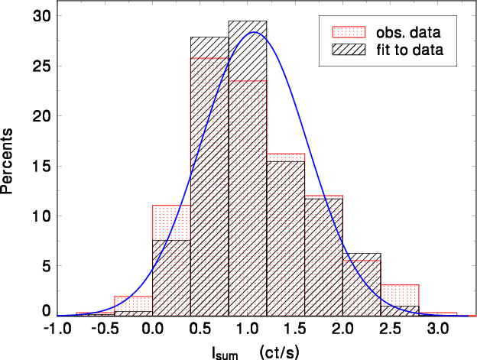
Figure 2-1: rwejrjwler jwelk
Table ‎3.1: Example
Heading | Heading
Test | Text

Summary of Works Completed

discussion

Introduction

Achievements (What you gained out of the attachment)

Capability of Existing Technology Practicing in Industry

Limitation of Existing Technology Practicing in Industry

Recommendation to Overcome the Challenges

Need of Life-Long Learning
Explain how the gap between your academic studies related to the modern technology used in industry and recognizing the need for continuing education and participation in the broadest context of technological change.

Conclusion

Conclusion

Concluding remarks
[A concluding remark is the last sentence of the conclusion in report. It is called a concluding remark because it sums up the entire purpose of the work in brief. As the name suggests, this remark wraps up the entire work with a period at the end.]

Appendix-A: Approval Letter
[Please attach the industrial attachment approval in this page]

Appendix-B: Certificate
[Please attach the certificate in this page]

Appendix-C: Pictorial view of some moment during attachemnt
[In this page, you have to attach some pictures that showing your attachment work]

