Knowledge and Technology

Bangladesh army UNIVERSITY

OF engineerIng & technology

qadirabad, natore



Department of Electrical and electronic engineering

A thesis report on

Please Provide a Concise and Specific Title that Clearly Reflects the Content of the Report

**NAME OF CANDIDATE**

Fall 2023

Th_EEE: 02_01_04 (Thesis_Departmental code_Batch_Id of 1st Student_ID of 2nd Student)

**Title of the Thesis**

A thesis paper submitted to the Department of Electrical and Electronic Engineering, Bangladesh Army University of Engineering & Technology, Qadirabad, Natore, in partial fulfilment of the requirements for the degree of “Bachelor of Science”in Electrical and Electronic Engineering.

**Name of Author 1**

**&**

**Name of Author 2 (if)**

**Month, Year**

Department of Electrical and Electronic Engineering

Bangladesh Army University of Engineering & Technology

Qadirabad, Natore- 6431, Bangladesh

**Title of the Thesis**

**Author**

Name of Author 1

ID:

Dept. of Electrical and Electronic Engineering

Bangladesh Army University of Engineering & Technology

**Author**

Name of Author 2

ID:

Dept. of Electrical and Electronic Engineering

Bangladesh Army University of Engineering & Technology

**Supervisor**

Name of the Supervisor

Designation

Dept. of Electrical and Electronic Engineering

Bangladesh Army University of Engineering & Technology

**Internal**

Name of the Internal

Designation

Dept. of Electrical and Electronic Engineering

Bangladesh Army University of Engineering & Technology

**Month, Year**

Department of Electrical and Electronic Engineering

Bangladesh Army University of Engineering & Technology

Qadirabad, Natore- 6431, Bangladesh

**STATEMENT OF ORIGINALITY**

This thesis has not published anywhere in full or partial part. Also this thesis has not submitted earlier as an undergraduate thesis. The authors manipulated this thesis from fundamental concept of antenna with vastly study antenna books, related papers and journals. All items, or sub items that appeared on this thesis are referenced where needed. This thesis can’t be copied without the permission of the authors.

The above announced statements are completely true. This undergraduate thesis work that has been submitted for evaluation of undergraduate thesis.

Date: 27, March, 20..

**Authors**

Abstract

(Please delete this part): Abstracts should be up to 300 words long and provide a succinct summary of the entire work. Although the abstract should explain why the report/article might be interesting, the importance of the work should not be over-emphasized. Citations should not be used in the abstract. Abbreviations, if needed, should be spelled out. For original research, we suggest that (if applicable) abstracts are structured into **Background, Methods, Results, and Conclusions.**

**Example Abstract:** Magnetic resonance-based wireless power transfer system offers a promising solution to overcome power limitations typically encountered by capsule endoscopy. Despite of much attentions in this area, aspects such as power stability and power transfer efficiency remain suboptimal and therefore investigation for further improvement is still required. This paper presents a method to improve power stability as well as power transfer efficiency for wireless capsule endoscopy. A new power transmission coil capable of producing uniform magnetic field is proposed to improve power stability through uniform field which at the same time minimizes the unnecessary peak electromagnetic exposure. To improve power transfer efficiency, a mixed resonance scheme is employed. Our experimental results show improvement over existing methods where the proposed system attained power stability of 94.62% and power transfer efficiency of 4.9% under worst position of the receiving coil. Furthermore, the proposed transmitting coil provides additional advantage, where it minimized the unnecessary peak electromagnetic exposure by 26% as compared to the conventional Helmholtz coil based system. We believe the proposed system will open new direction for future wireless capsule endoscopy and can

also be useful in other industrial applications.

Acknowledgements

**Example Acknowledgements**: My deepest thanks to the Almighty Allah S.W.T. (Alhamdulillah), the Omnipotent, the Merciful and the Compassionate, for giving me the strength, patience and determination in compiling this research. Then, I would like to express my gratefulness to my supervisor, Dr. Mohd Fareq Bin Abd Malek for his valuable and constructive suggestions thought this thesis that enabled it to run smoothly. Prof. Dr. R. Badlishah Ahmad provided excellent research facilities under the school of computer and communication engineering. I also deeply grateful to the Ministry of Higher Education, Malaysia, for providing financial support for this thesis work under the grant FRGS/FASA/TAHUN/SKK/JPP/03/6 via Politeknik Tuanku Syed Sirajuddin and Khairudi Mohd Juni for managing this grand. I would like to share this moment of contentment and express the appreciations to my parents who were encouraged at every step in my life. I am very much indebted to my cousin Md. Azabul Haque, for his guidance and great source of motivation in my higher study. I owe a special gratitude to the Bangladesh community in Perlis specially to Dr. Fazlul Bari and Md. Mohiuddin for their mental support. Finally, I thank everyone else who has facilitated the making of this thesis, including other colleagues. (Please delete this part)

Table of Contents

Abstract v

Acknowledgements vi

Table of Contents vii

List of Figures ix

List of Tables x

List of Symbols and Abbreviations xi

List of AppendEEEs xii

CHAPTER 1: Introduction 1

1.1 Background (heading 2, h2) 1

1.2 Problem Statement (heading 2, h2) 1

1.3 Motivation (heading 2, h2) 1

1.4 Research Objective (heading 2, h2) 1

1.5 Organization of this thesis (heading 2, h2) 2

1.5.1 Second Subtitle (Heading3, h3) 2

1.5.1.1 Third subtitle (Heading4, h4) 2

CHAPTER 2: Literature review 3

2.1 Introduction 3

2.2 Review of Existing Work 3

2.3 Critical Analysis of Existing Work 3

2.4 Limitation of Existing Work and Justification 3

2.5 Conclusion 3

CHAPTER 3: Methodology/modeling/design 4

3.1 Introduction 4

3.2 Investigation on Different Methods 4

3.3 Selection of Appropriate Method with Justification 4

3.4 Research/Project Management and Finance 4

3.5 Figure and Table 4

3.5.1 Figure 4

3.5.2 Table 5

3.5.3 Equation 6

3.5.4 Citation 6

CHAPTER 4: Result and discussion 8

4.1 Introduction 8

4.2 Conclusion 8

CHAPTER 5: Conclusion 9

5.1 Concluding remarks 9

5.2 Original Contribution of this Work 9

5.3 Recommendation for further contribution 9

References 10

List of Publications and Papers Presented 12

Appendix 13

List of Figures

(Please delete this part): This list contains the titles of figures, together with their page numbers, which are listed in the text. For e.g., figures in Chapter 3 are numbered sequentially: Figure 3.1, Figure 3.2.

For title of list tables use *other title* and *TOC1* for style.

Figure ‎3.1: Example 2

List of Tables

(Please delete this part): This list contains the titles of tables, together with their page numbers, which are listed in the text. The numbering system is according to chapter, for e.g.: tables in Chapter 3 are numbered sequentially: Table 3.1, Table 3.2.

Table ‎2.1: Example 2

List of Symbols and Abbreviations

**Example for List of Symbols:**

|  |  |  |
| --- | --- | --- |
| *V* | : | Voltage |
| *I* | : | Current |
| *λ* | : | Wavelength |
|  |  |  |
|  |  |  |

**Example for List of Abbreviations:**

|  |  |  |
| --- | --- | --- |
| CC | : | Central canal |
| DAB | : | 3,3’-diaminobenzidine |
| HRP | : | Horseradish peroxidase |
| MS222 | : | Tricaine methanesulfonate |
|  | : |  |
|  | : |  |
|  |  |  |
|  |  |  |

List of AppendEEEs

|  |  |
| --- | --- |
| Appendix A: Example ……………………………………………………………... | 7 |
|  |  |
|  |  |
|  |  |
|  |  |
|  |  |
|  |  |

# Introduction

The body of the text should be typed with Times New Roman 12 front size and 1.5 line spacing and paragraph’s alignment should be “Justified”. Single-spacing is only permitted in tables, long quotations, footnotes, and in the bibliography.

## Background

First topic in each chapter should numbered with “chapter number”.1. Use Heading 2 or h2 for title and for table of content TOC must be used.

The background of the study is a part of a research provided in the introduction section of the paper. ... In summary, a good background of the study is the work done to determine that your research question or thesis topic is a problem and that the method used is the one required to solve the issue or answer the question.

## Statement of Complex Engineering Problem

Problem statement is a concise description of an issue to be addressed or a condition to be improved upon. It identifies the gap between the current (problem) state and desired (goal) state of a process or product. Focusing on the facts, the problem statement should be designed to address. The first condition of solving a problem is understanding the problem, which can be done by way of a problem statement.

## Motivation

Interest for increasing knowledge motivates people to do research in their own field. Research adds to the existing knowledge in a systematic way. The quest for knowledge is therefore an important motivating factor in social research. Discovering the truth always forces man to undertake research in own society.

## Research Objective

Research objectives describe concisely what the research is trying to achieve. They summarize the accomplishments a researcher wishes to achieve through the project and provides direction to the study. A research objective must be achievable, i.e., it must be framed keeping in mind the available time, infrastructure required for research, and other resources. Before forming a research objective, you should read about all the developments in your area of research and find gaps in knowledge that need to be addressed. This will help you come up with suitable objectives for your research project.

## Organization of this thesis

An organizational statement is a map that tells your reader what h/she should expect to read in your essay. It introduces the two or three main pieces of evidence that you will use to support your position. While not required in a thesis, organizational statements can make for stronger thesis statements.

### Second Subtitle

For first subtopic in each chapter use Heading 3 or h3 for title and for table of content TOC4 must be used

#### Third subtitle

For second subtopic in each chapter use Heading 4 or h4 for title and for table of content TOC5 must be used.

##### Other subtitles

For other subtopics in each chapter use Heading 5 or h5 for title, and number them with (a),(b),… and for table of content TOC6 must be used.

# Literature review

## Introduction

A literature review is a survey of scholarly sources on a specific topic. It provides an overview of current knowledge, allowing you to identify relevant theories, [methods](https://www.scribbr.com/category/methodology/), and gaps in the existing research.

Writing a literature review involves finding relevant publications (such as books and journal articles), critically analyzing them, and explaining what you found. There are five key steps:

1. **Search** for relevant literature
2. **Evaluate** sources
3. **Identify** themes, debates and gaps
4. **Outline** the structure
5. **Write** your literature review

A good literature review doesn’t just summarize sources – it analyzes, [synthesizes](https://www.simplypsychology.org/synthesising.html), and critically evaluates to give a clear picture of the state of knowledge on the subject.

## Review of Existing Work

Analyze the current workflow Your goal here is to figure out how you have been operating so far and what you have been doing wrong. Talk to your employees, ask them for their feedback on each process or workflow that your business follows. Analyze every aspect and document every detail for the upcoming steps.

## Critical Analysis of Existing Work

This means deciding whether you agree or disagree with certain viewpoints, arguments and theories, rather than simply describing them.

## Conclusion

# Methodology/modeling/design

## Introduction

Research methodology is the specific procedures or techniques used to identify, select, process, and analyze information about a topic. In a research report, the methodology section allows the reader to critically evaluate a study's overall validity and reliability.

## Investigation on Different Methods

Step 1: Explain different available methodological approach to solve this problem. Begin by introducing your overall approach to the research.

## Selection of Appropriate Method with Justification

Step 2: Describe your methods of data collection. ...

Step 3: Describe your methods of analysis. ...

Step 4: Evaluate and justify your methodological choices

## Research/Project Management and Finance

Explain your time schedule and financial budget (if any), proposed and actual.

## Design and Development of Solution

## Figure and Table

Figure and table number, caption, and citation of this document will be automatically updated within the body of thesis as well as in the list of figure and table of the table of contain section like chapter and heading. Therefore, using adding or citing figure and table should follow the procedure below.

### Figure

**Adding figure caption:** select the figure🡪 right click on the mouse🡪 select *insert caption*🡪 chose figure from the “Label”🡪and select position “below selected item”🡪 choose the “numbering” option🡪 tick mark on the “include chapter number”🡪use separator “period”

**Citing the figures in within the text:** take your couture where you want to cite the figure🡪 go to “References” button form top🡪 click to “Cross reference”🡪 select figure from “reference type”🡪 select only label and number from “insert reference to”🡪 select the figure you want to cite form the below box.

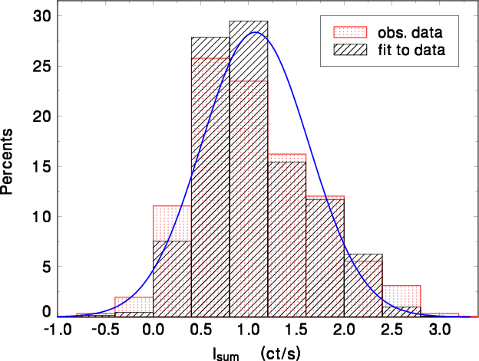

Figure 3‑1: Example

**Figures** should be printed within the body of the text at the center of the frame and labelled according to the chapter in which they appear. Thus, for example, figures in Chapter 3 are numbered sequentially: Figure 3.1, Figure 3.2 etc. Figure should be neat and clean with 300x300 dpi minimum resolution and adequate clear labeling.

### Table

The insertion of table caption and citing of table within the body should follow the same procedure of figure except the caption for table is shown on the top of the table.

**Tables** are printed within the body of the text at the center of the frame and labeled according to the chapter in which they appear. Thus, for example, tables in Chapter 2 are numbered sequentially: Table 2.1, Table 2.2.

The label should be placed above the table itself and has the following format:

Table ‎3.1: Example

|  |  |
| --- | --- |
| **Heading** | **Heading** |
| Test | Text |
|  |  |

### Equation

**Equation** should be typed using Microsoft equation 3.0 from the “Insert”🡪 “object”🡪 “Microsoft equation 3.0”. The equation number should be within parentheses, are to position flush right, including the chapter number as in (3.1). To make your equations more compact, you may use single raw three column table without border as in:

|  |  |  |
| --- | --- | --- |
|  |  | (3.1) |

Note that the equation is centered. Be sure that the symbols in your equation have been defined before or immediately following the equation. For citation of equation in paragraph, use “(1)”, not “Eq. (1)” or “equation (1)”, except at the beginning of a sentence: “Equation (1) is . . .”

### Citation

When writing a piece of academic work, you must acknowledge any sources which you have used. You do this by including a brief in-text ‘citation’ within the main body of your writing, next to the material you have used. The IEEE style is a numeric style, where citations are numbered [1] in the order of appearance. This citation leads your reader to a full reference to the source in the list of references at the end of your work. Each citation number should be enclosed in square brackets on the same line as the text, before any punctuation, with a space before the bracket [2]. Once a source has been cited, the same number is re-used for all subsequent citations to the same source.

Here are some examples of IEEE style citation: “... as shown by Brown [4], as previously stated.” "The theory was first put forward in 1987 [1]." “For example, see [7].”

"Several recent studies [3, 4, 15, 16] have suggested that..." The example above may also be formatted as: “Several recent studies [3], [4], [15], [16] have suggested that…”

Page numbers are required within citations where material is directly quoted or you refer to a specific part of the source, such as a detail difficult to find. Give page numbers within the square brackets, for example [1, p. 3].

At the end of your work, list full details of all of the sources which you have cited in your text in a section headed **References**, in numeric order.

# Result and discussion

## Introduction

**Add necessary sub heading in this section in according to your thesis.**

Study results normally refer to direct answers to your research questions that you generate from the data. Discussion is about interpreting your study results. When you discuss the study results, you relate your study findings to previous studies; you contextualize the contribution of your study.

Difference between result, discussion and conclusion

**Results** section is just a presentation of the data in the form of graph or tabular data. There should not be any discussion in the results section (that goes in the discussion section). The results need to be presented in enough detail for someone not familiar with the scientific paper to understand them.

**Discussion** unrolls the main results, explain their meanings. Put there the new questions and perspectives, describe the most interesting points for the entire field. Define the possible answers, write down why and how and what for, your suggestions.

**Conclusion** is a summary of the discussion or the whole work. You can put there the main points and results, their factual meaning for the field and a possible further direction. I like to describe this as "discussion's points and facts without the discussion."

## Conclusion

# Conclusion

## Concluding remarks

A concluding remark is the last sentence of the conclusion in an research. It is called a concluding remark because it sums up the entire purpose of the research in brief. As the name suggests, this remark wraps up the entire research with a period at the end.

## Original Contribution of this Work

The original contribution made by this research work has to be mentioned clearly.

## Recommendation for further contribution

To facilitate the assessment and promotion of integrity in the research environment, the committee makes several recommendations, which are presented in the sections that follow. In combination, these recommendations are aimed at efforts to foster integrity in research at the individual and institutional levels and to ensure continuous institutional self-assessment and quality improvement.

References

(Please delete this part): The references should be written consistently in the IEEE format. The style and example of IEEE format for different sources has been given below.

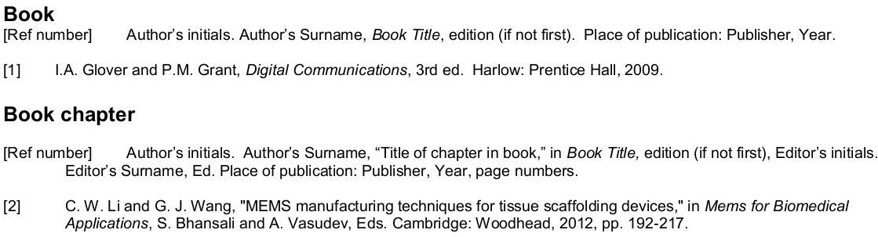

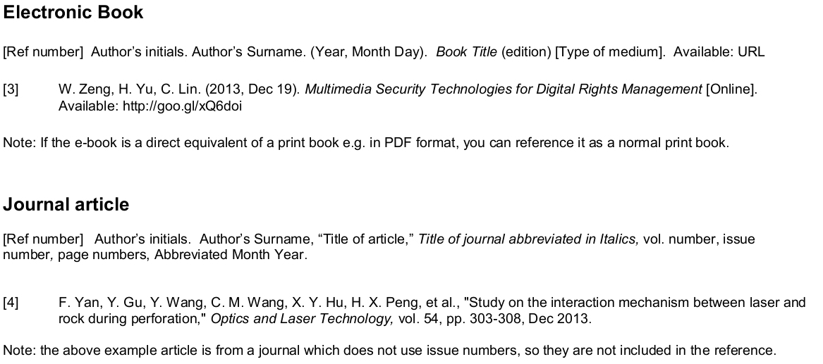

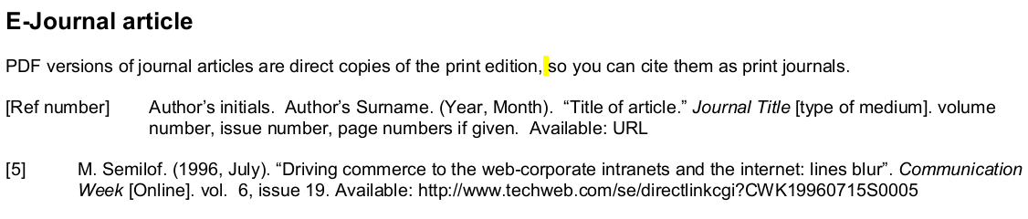 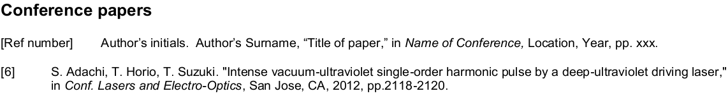

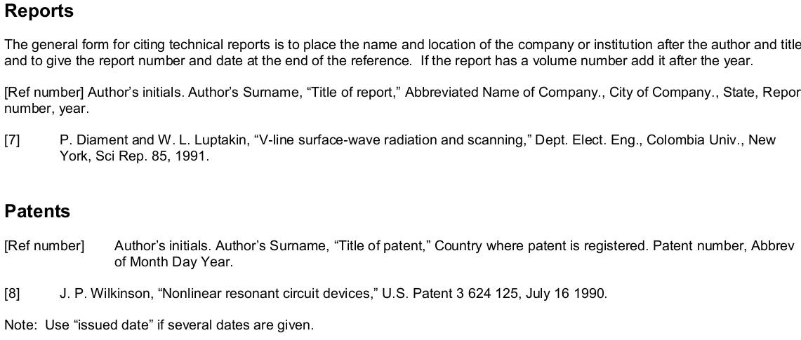

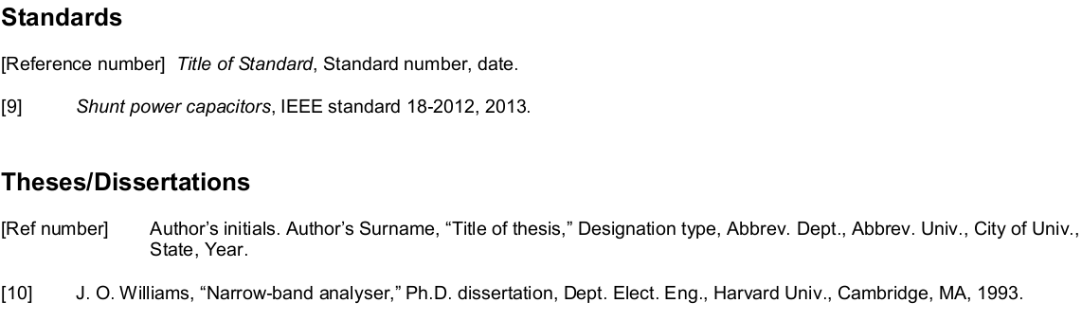 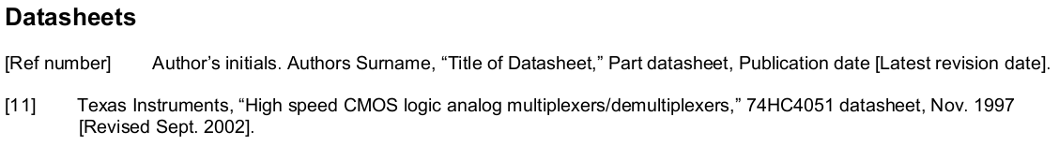 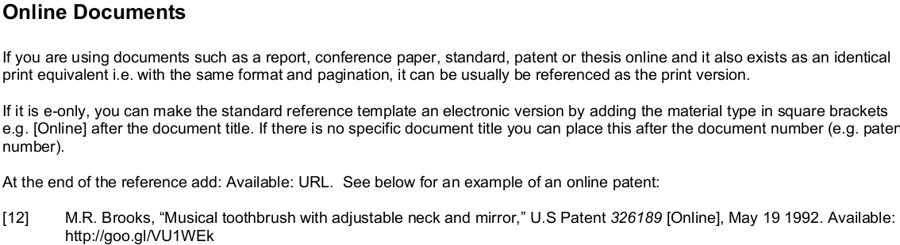 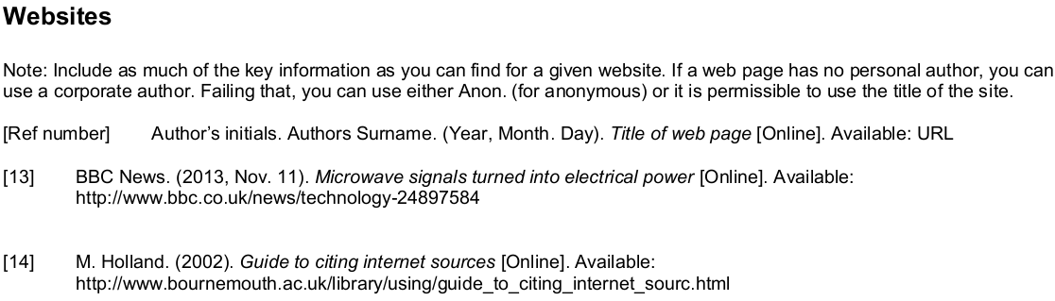

List of Publications and Papers Presented

Published works as well as papers presented at conferences, seminars, symposiums etc pertaining to the research topic of the research report/ dissertation/ thesis are suggested be included in this section. The first page of the article may also be appended as reference.

Appendix

(Please delete this part): AppendEEEs consist of additional illustration of data sources, raw data and quoted citations which are too long to be placed in the text. The appendix supports the written text of the research report/dissertation/thesis. Research instruments such as questionnaires, maps or computer programmes are parts of appendix too.

AppendEEEs can be divided into Appendix A, B, C.

This page is optional; if you do not have any appendEEEs, delete the entire page.