Bangladesh Army University of Engineering & Technology (BAUET)
Qadirabad Cantonment, Natore-6431



Thesis Proposal
On
Title of the Thesis

Submitted By: | Submitted To:
- Name:…………. (ID:……)  - Name:…………. (ID:……)  - Name:…………. (ID:……) | - Main Supervisor: Name & Designation  - Co-Supervisor (if any): Name & Designation
Student of Batch: | Department:
Course Code: | Credit Hours:
Course Title: | Date of Submission:
Academic Semester:
Remarks

Date & Signature of Evaluator

Department of Electrical and Electronic Engineering (EEE)

Table of Contents
1. Executive Summery/Background/Introduction 3
2. Literature Review 3
3. Critical Analysis and Problem Statement 3
4. Objectives 4
5. Brief Methodology 4
6. Milestone 5
7. Budget 5
8. Conclusion 6
9. Reference List 6
10. Declaration 6

1. Executive Summery/Background/Introduction
Start this section with a short and clear background information of your topic that could help to understand the context of your research. Give a brief problem statement indicating the purpose or scope of this research with hypothetical significant of this research. Write this section within 10-15 lines. You are encouraged to add a graphical overview or diagram if possible like in the figure 1.
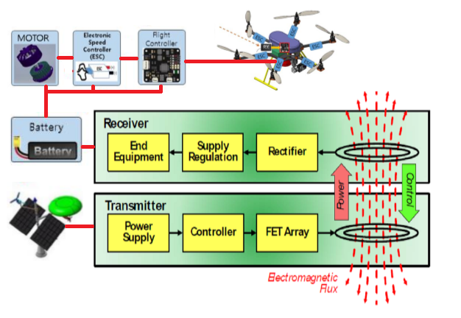
Figure 1: Overview of AI based drone system with wireless charging by inductive power transfer.

2. Literature Review
In this section you have to present a summary of literature review. In this regard, you are required to review and present the summery of at least 10 recent article most of them should be high impact journal article. You may present a summary of important reviewed data in tabular form along with enough expiation and required citation.

3. Critical Analysis and Problem Statement
In this section you have to give your own comments based on critical analysis of existing work indicating the complex problem based on you are going to set your research objectives.

4. Objectives

In this section you have to write clear and concise objective of your research. An Example is as below.
In this research proposal, we want to develop AI based surveillance mini-Drone with automated charging by wireless power transfer system for continuous operation of unlimited time for remote surveillance and/or telecommunication network monitoring. To accomplish this goal our research work is opted into the following objectives:

- To model and prototype miniaturized light weight AI based drone with precision mission control with long range control and data communication.
- To develop android based appropriate controlling interface to control the operation of drone.
- To design a light weight automated inductive wireless power transfer system-based drone charging system for automatically recharging drone’s batter when needed.
- To implement and test the whole system and rectify for improvement.

Brief Methodology
In this section you have to explain brief methodology of your thesis. One example is as below.
The brief methodology of proposed research has been illustrated in Figure 2. The work will be started with extensive literature review and critically analysis on review works.
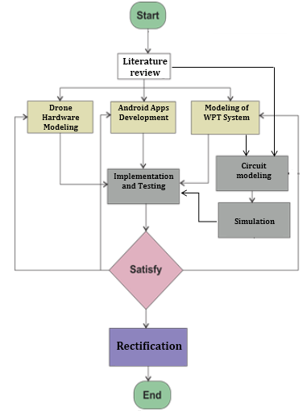
Figure 2. Flowchart of research methodology
Based on outcome of critical analysis of existing literature Drone will be modeled and prototyped. Artificial Intelligence will be implemented in Drone for automatic mission control and finding auto charging location as well as charging. An android apps will be developed to control the drone based on internet of thing (IoT) technology via 4G mobile network. For wireless power transmission system, a pair of transmitting and receiving coil will be designed and optimized for maximum power transfer efficiency with the help of simulation software. At the same time, the power transmitting and receiving circuit will be modeled and fabricated with the help of industrial support. Finally, all the individual part will be implemented, integrated and tested. Necessary rectification will be done for further improvement of results.

Milestone
The Gantt chart of proposed research is following:
Tasks |  | Project Duration (12 Months)
 |  | Semester-1 |  |  |  |  |  | Semester-2
 |  | Month 1 | Month 2 | Month 3 | Month 4 | Month 5 | Month 6 | Month 7 | Month 8 | Month 9 | Month 10 | Month 11 | Month 12
1 | Task 1
2 | Task 2
3 | Task 3
4 | Task 4
5 | Task 5
6 | Task 6
7 | Task 7
8 | Task 8
9 | Task 9
10 | Task 10

Task | Description
Task 1 | Literature Review
Task 2 | Modeling and implementation of AI based drone hardware
Task 3 | Android Apps development for controlling drone
Task 4 | Implementation of AI in drone hardware
Task 5 | Modeling of wireless power transfer (WPT) system for drone charging
Task 6 | Modeling transmitter and receiver coil for WPT system
Task 7 | Modeling of inverter and rectifier circuit for power transmitter and receiver
Task 8 | Fabrication of inductive power transfer system
Task 9 | Testing and optimization of overall AI based drone and wireless charging system
Task 10 | Report writing and paper publication

Budget
You have to present a realistic budget for your research. One example is as below.
Si | Particulars | Estimated Budget
1 | Purchasing research materials  - Drone hardware materials  - Android module  - Wireless power transfer coil materials  - Inverter and rectifier circuit materials | 120,000/-  20,000/-  30,000/-  60,000/-
2 | Android apps development | 20,000/-
3 | Allowance and honorarium  - Allowance for researcher  - Honorarium on publication or novel achievement | 60,000/-  40,000/-
4 | Conference/Seminar and Publication  - Attending conference/Seminar  - Journal article publication | 45,000/-  50,000/-
Total |  | 4,45,000/-
In Word: Four lac forty-five thousand only.

Conclusion
Give a concluding remark of your research proposal.

Reference List
List all of your references in IEEE style like below.
[1] M. Wazid, B. Bera, A. Mitra, A. K. Das, and R. Ali, "Private blockchain-envisioned security framework for AI-enabled IoT-based drone-aided healthcare services," in Proceedings of the 2nd ACM MobiCom Workshop on Drone Assisted Wireless Communications for 5G and Beyond, 2020, pp. 37-42.

Declaration
We are declaring that this proposal is original and not submitted anywhere else. To the best of our knowledge there is not conflict government and BAUET policy.
Signature & Date

Name of Student-1  ID of Student-1 |  | Name of Student-2 …..  ID of Student-2…

Assessment Marks

CO-PO | Criteria | Excellent  (80%-100%) | Good  (60%-79%) | Satisfactory  (40%-59%) | Inadequate  (0%-39%) | Supervisor | Course  Teacher | Average
CO1  PO2 | Literature Review  (4) | Comprehensive, critical, current sources; clear gaps identified | Good coverage; minor gaps/limited critique | Basic review; limited analysis; some outdated sources | Incomplete; irrelevant; no critical analysis
CO1  PO2 | Problem Statement  (3) | Clear, focused, well-aligned with literature; addresses complexity | Mostly clear; minor scope/clarity issues | Vague; partial alignment | Unclear or disconnected
CO1  PO2 | Objectives  (3) | Specific, measurable, well-aligned; strong understanding | Clear; minor alignment/depth issues | General or incomplete | Missing or poorly defined
Total

